**[next →](https://www.javatpoint.com/git-fork)**[**← prev**](https://www.javatpoint.com/git-stash)

Git Ignore

In Git, the term "ignore" is used to specify intentionally untracked files that Git should ignore. It doesn't affect the Files that already tracked by Git.

Sometimes you don't want to send the files to Git service like GitHub. We can specify files in Git to ignore.

The file system of Git is classified into three categories:

**Tracked:**

Tracked files are such files that are previously staged or committed.

**Untracked:**

Untracked files are such files that are not previously staged or committed.

**Ignored:**

Ignored files are such files that are explicitly ignored by git. We have to tell git to ignore such files.

Generally, the Ignored files are artifacts and machine-generated files. These files can be derived from your repository source or should otherwise not be committed. Some commonly ignored files are as follows:

* dependency caches
* compiled code
* build output directories, like /bin, /out, or /target
* runtime file generated, like .log, .lock, or .tmp
* Hidden system files, like Thumbs.db or.DS_Store
* Personal IDE config files, such as .idea/workspace.xml

Git Ignore Files

Git ignore files is a file that can be any file or a folder that contains all the files that we want to ignore. The developers ignore files that are not necessary to execute the project. Git itself creates many system-generated ignored files. Usually, these files are hidden files. There are several ways to specify the ignore files. The ignored files can be tracked on a **.gitignore** file that is placed on the root folder of the repository. No explicit command is used to ignore the file.

There is no explicit git ignore command; instead, the .gitignore file must be edited and committed by hand when you have new files that you wish to ignore. The .gitignore files hold patterns that are matched against file names in your repository to determine whether or not they should be ignored.

How to Ignore Files Manually

There is no command in Git to ignore files; alternatively, there are several ways to specify the ignore files in git. One of the most common ways is the **.gitignore** file. Let's understand it with an example.

The .gitignore file:

Rules for ignoring file is defined in the .gitignore file. The .gitignore file is a file that contains all the formats and files of the ignored file. We can create multiple ignore files in a different directory. Let's understand how it works with an example:

**Step1:** Create a file named .gitignore if you do not have it already in your directory. To create a file, use the command touch or cat. It will use as follows:

1. $ touch .gitignore

Or

1. $ cat .gitignore

The above command will create a .gitignore file on your directory. Remember, you are working on your desired directory. Consider the below command:

Git Ignore

The above command will create a file named .gitignored. We can track it on the repository. Consider the below image:

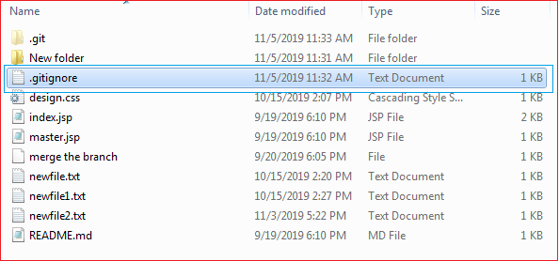

As you can see from the above image, a .gitignore file has been created for my repository.

**Step2:** Now, add the files and directories to the **.gitignore** file that you want to ignore. To add the files and directory to the .git ignore the file, open the file and type the file name, directory name, and pattern to ignore files and directories. Consider the below image:

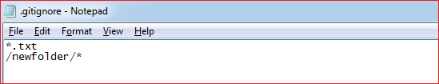

In the above file, I have given one format and a directory to ignore. The above format **\*.txt** will ignore all the text files from the repository, and **/newfolder/\*** will ignore the newfolder and its sub-content. We can also give only the name of any file to ignore.

**Step3:** Now, to share it on Git, we have to commit it. The .gitignore file is still now in staging area; we can track it by git status command. Consider the below output:

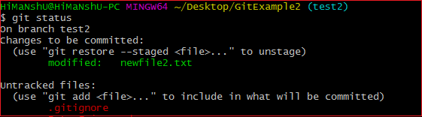

Now to stage it, we have to commit it. To commit it, run the below command:

1. $ git add .gitignore
2. $ git commit -m "ignored directory created."

The above command will share the file .gitignore on Git. Consider the below output.

Git Ignore  
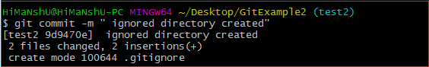

Now, we have ignored a pattern file and a directory in Git.

**Rules for putting the pattern in .gitignore file:**

The rules for the patterns that can be put in the .gitignore file are as follows:

* Git ignores the Blank lines or lines starting with #.
* Only the Standard glob patterns work and will be applied recursively throughout the entire working tree.
* The patterns can be started with a forward slash (/) to avoid recursively.
* The patterns can be ended with a forward slash (/) to specify a directory.
* The patterns can be negated by starting it with an exclamation point (!).

Global .gitignore:.

As we know that we can create multiple .gitignore files for a project. But Git also allows us to create a universal .gitignore file that can be used for the whole project. This file is known as a global .gitignore file. To create a global .gitignore, run the below command on terminal:

1. $ git config --global core.excludesfile ~/.gitignore_global

The above command will create a global .gitignore file for the repository.

How to List the Ignored Files?

In Git, We can list the ignored files. There are various commands to list the ignored files, but the most common way to list the file is the **ls command**. To list the ignored file, run the ls command as follows:

1. $ git ls-files -i --exclude-standard

Or

1. $ git ls-files --ignore --exclude-standard

The above command will list all available ignored files from the repository. In the given command, **-I** option stands for ignore and **--exclude-standard** is specifying the exclude pattern. Consider the below output:

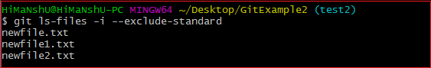

From the above output, we can see that the **ls** command is listing the available ignored files from the repository.